

**AFRICAN INSTITUTE FOR PROJECT MANAGEMENT STUDIES**

**Course: Post Graduate Course in Grants Management**

**Course Module: Module 3**

**Student Name: OKOT Charles**

**Admission Number: Aipms/300/2019**

**Module Submission Dateline: 30th /November/2019**

Module Three:

1. Discuss the following individuals who write project proposals clearly explaining the kind of proposals the write:  
   i) Programme officers in NGOs.

Programme offices in NGOs, are responsible designing humanitarian & development programs, fund raising, management of funds, initiating programs, implementing & monitoring progress and quality of programs, and ensuring successful closure of programs.

Therefore, a programme officer in NGOs write proposals with the intension of responding to either humanitarian or development to address gaps during emergencies or development context.

ii) Government officers

Government officers are employed by government to hold government offices. Government officers can write project proposals to supplementing government budgets, geared towards addressing gaps in funding National strategic plans.  
iii) Implementers of projects

Implementers of projects, are entities or organizations that are given the legal authority to make sure the designed and funded project are executed within a required timeframe, budget, scope and right quality.

Therefore implementers write proposals to clearly indicate how best the project shall be executed.

2. **Discuss four motivations that make grant makers (donors) to enter into grant making endeavors.**

The below discussions clearly outlined key motivations that grant makers to enter in to grant making endeavors;

* + 1. **Alignment of organization interventions or proposal to Grant makers mission and vision.**

Grant makers are motivated to fund organizations that can help them is achieving their goals, so there is need for a proposal to show how your organizations values align with theirs. Grant makers like to work with organizations who they share a similar passion with and who they are confident are working in pursuit of the same goals. Therefore, before you even begin to write an application it is important to understand what shared values the two organizations have and how you can emphasize them in a project proposal.

* + 1. **Track Record of Similar Achievements.**

The experience and capacity of your organization orthe current status and reputation of your organization within the community that you work can motivate grant makers to fund your projects. Grant makers will be able to find information about your organization from newspapers and websites as well as contacting organizations you have worked with in the past to see what they have to say about your NGO. An organizations’ past track record can be a massive advantage as a grantee, so making sure to include information on website about who has supported an organization in the past carries a big weight.

* + 1. **Impact of proposal.**

The impact that your proposed project will make on the community can motivate the grant makers to fund your project. also considering the methods and approaches that an NGO/Proposal typically uses to deliver their projects. funder will also evaluate if whether your project fits within their current priorities in terms of beneficiaries, location, delivery method and magnitude of impact the project will create on the target group.

* + 1. **Project Self-sustainability.**

Because of limited funding, grant makers look for projects that can sustain their goals and vision, the fore how you will sustain your project after the funding period ends, and have a well-developed exit strategy motivates the grant maker. Most funders will only supply initial seed funding so it is fundamentally important that you can provide a realistic explanation of how to the project will become self-sustainable.

1. **Briefly discuss four factors to consider when writing a problem statement of a development project proposal.**

It is useful to design and follow a specific format when writing a problem statement. While there are several options for doing this, the following is a simple and straightforward template often used in Business Analysis to maintain focus on defining the problem.

1. **IDEAL:** This section is used to describe the desired or “to be” state of the process or product. It identifies the goals of the stakeholders and customers as well as assists in defining scope. At large, this section should illustrate what the expected environment would look like once the solution is implemented.
2. **REALITY:** This section is used to describe the current or “as is” state of the process or product. It explains the pain points expressed by the stakeholders and customers. It should also include the insights and expertise of the project team and subject matter experts provided during problem analysis.
3. **CONSEQUENCES:** This section is used to describe the impacts on the business if the problem is not fixed or improved upon. This includes costs associated with loss of money, time, productivity, competitive advantage, and so forth. The magnitude of these effects will also help determine the priority of the project.
4. **PROPOSAL:** This section is used to describe potential solutions. Once the ideal, reality, and consequences sections have been completed, understood, and approved, the project team can start offering options for solving the problem. It can also include suggestions by the stakeholders and customers, although further discussions and research will be needed before a specific course of action can be determined.

**4. What do you understand by the logical framework?**

The Logical Framework Approach is an analytical process and set of tools used to support project planning and management. It provides a set of interlocking concepts which are used as part of an iterative process to aid structured and systematic analysis of a project or programme idea.

**Typical structure of a Log frame Matrix**

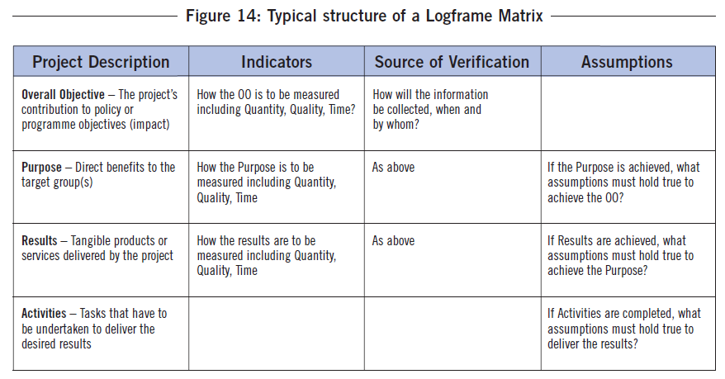

**5. What are the components of a winning proposal? Explain three.**

A proposal is a formal document submitted to a government or civilian entity that outlines a proposed project and shows budgetary requirements and requests monetary assistance in the form of a grant.

The following are some key components of a good proposal;

* Title Page and Cover Letter
* Introduction/Abstract/Summary
* Institutional Background
* Problem Statement/Needs Assessment
* Program Goals and Objectives (Outcomes)
* Methods/Implementation Plan
* Evaluation Plan
* Future Funding/Sustainability
* Budget
* Other Components/Annexes

The explanation shall cover, institutional Background, Problem statement, Program Goals and objectives and Methods/Implementation plan;

* + 1. **Institutional Background**

Describes the institution in terms of its location, demographics, mission, relationship to the service area and past successes in the project area. Establishes credibility.

* + 1. **Problem Statement/Needs Assessment**

Documents the problem or need with hard data, linking it to the funding source’s goals and priorities. What is the situation that is causing concern? Why is it happening?

* + 1. **Program Goals and Objectives (Outcomes)**

Identifies anticipated outcomes and benefits in measurable terms. How is the situation expected to change as a result of the grant program?

* + 1. **Methods/Implementation Plan**

Describes the activities that directly support the achievement of the objectives. A timeline may be included in this section as well as a description on staffing needs.

Reference;

1. Proposal writing training manual for cbos and ngos by USAID & IRC.
2. Ruth Tebbets Brousseau (2004). Experienced Grant makers at Work *January 2004*. Retrieved from <http://foundationcenter.org/gainknowledge/research/pdf/practicematters>*_05_paper.pdf*
3. A guide to the project management body of knowledge (PMBOK® guide). -- Fifth edition. pages cm Includes bibliographical references and index.
4. Jim Wrenn (2014). Grant Management Problems and Red Flags 2014. Retreived from <https://www.itworks-inc.com/2014/03/12/grant-management-problems-red-flag>. 30/11/2019.